# On-Premises Deployment by setting up Web Server, IIS, SQL Database Server.

Step:1-Install IIS server in the windows System.So go to the Control panel and click on Program and Features.

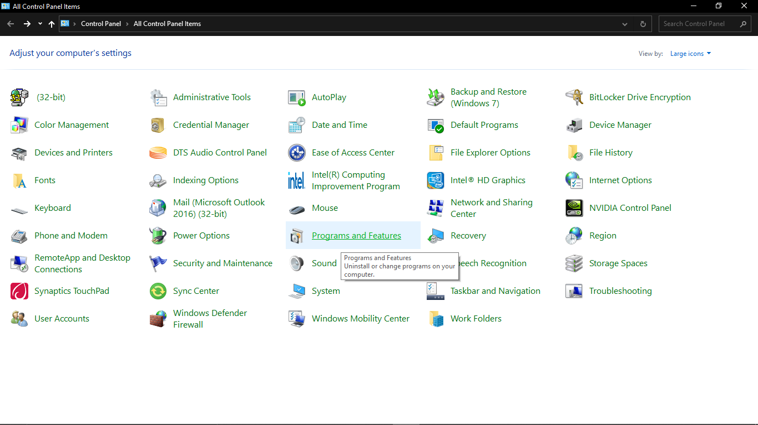

Then Click on the Turn windows features on and off.

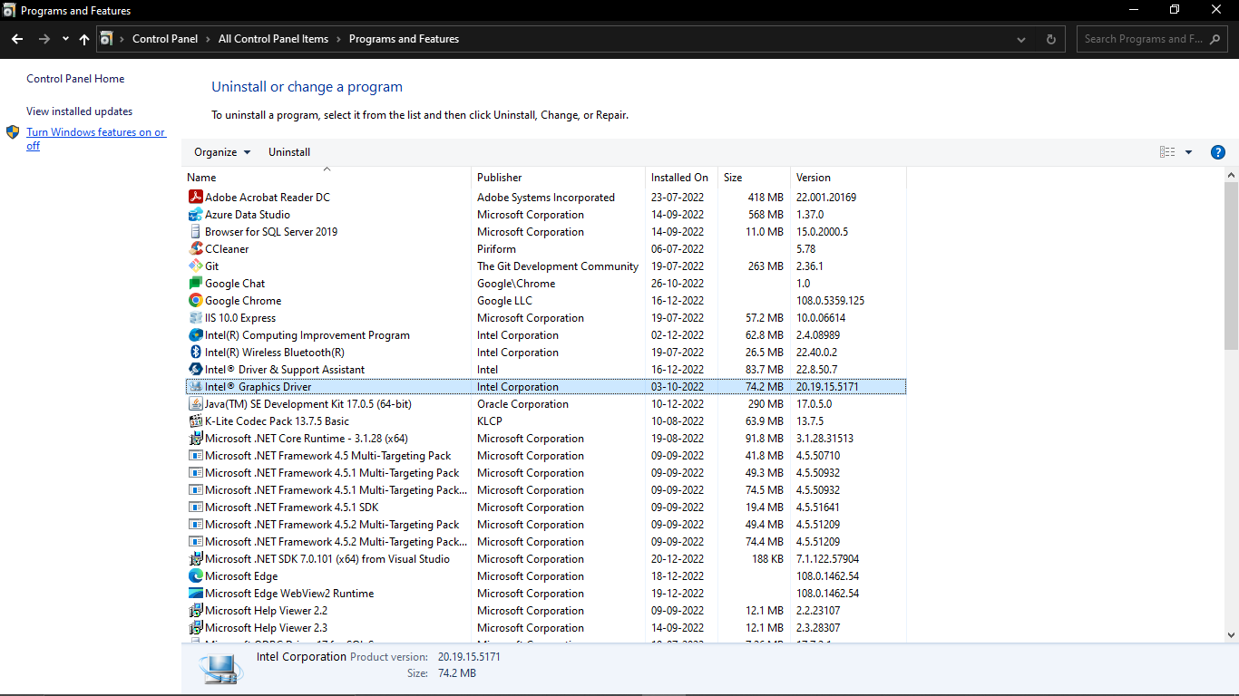

Step 2:- Now one pop up window will open then search for the **Internet Information Services** and then select the services required as shown in the Picture Below.

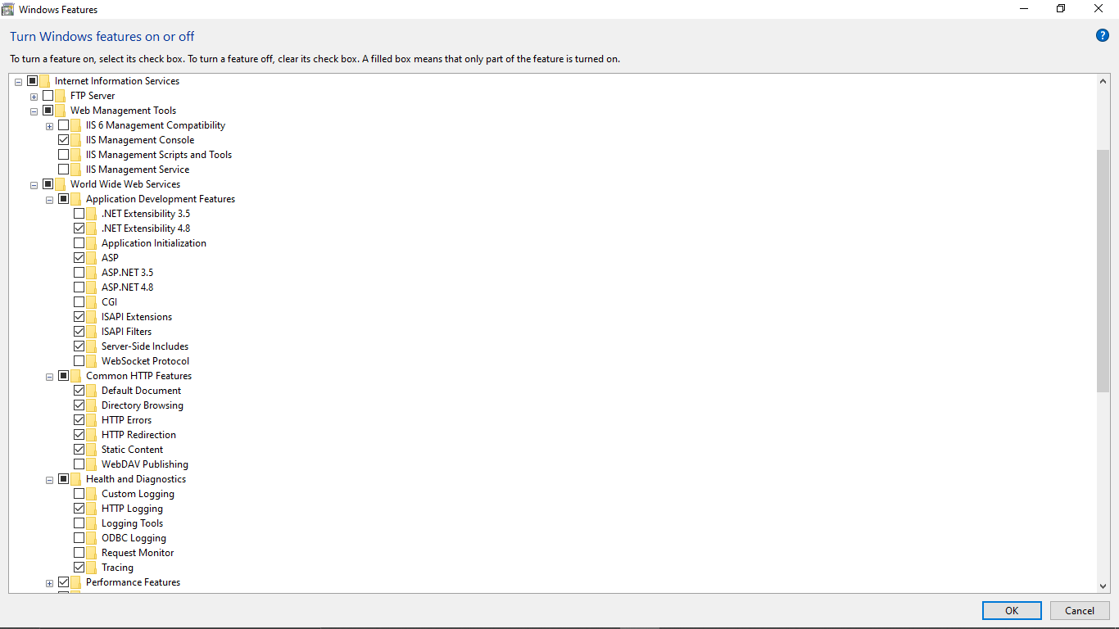

Then click on OK

Here we will get the IIS 10.0 Express Installed in our PC.

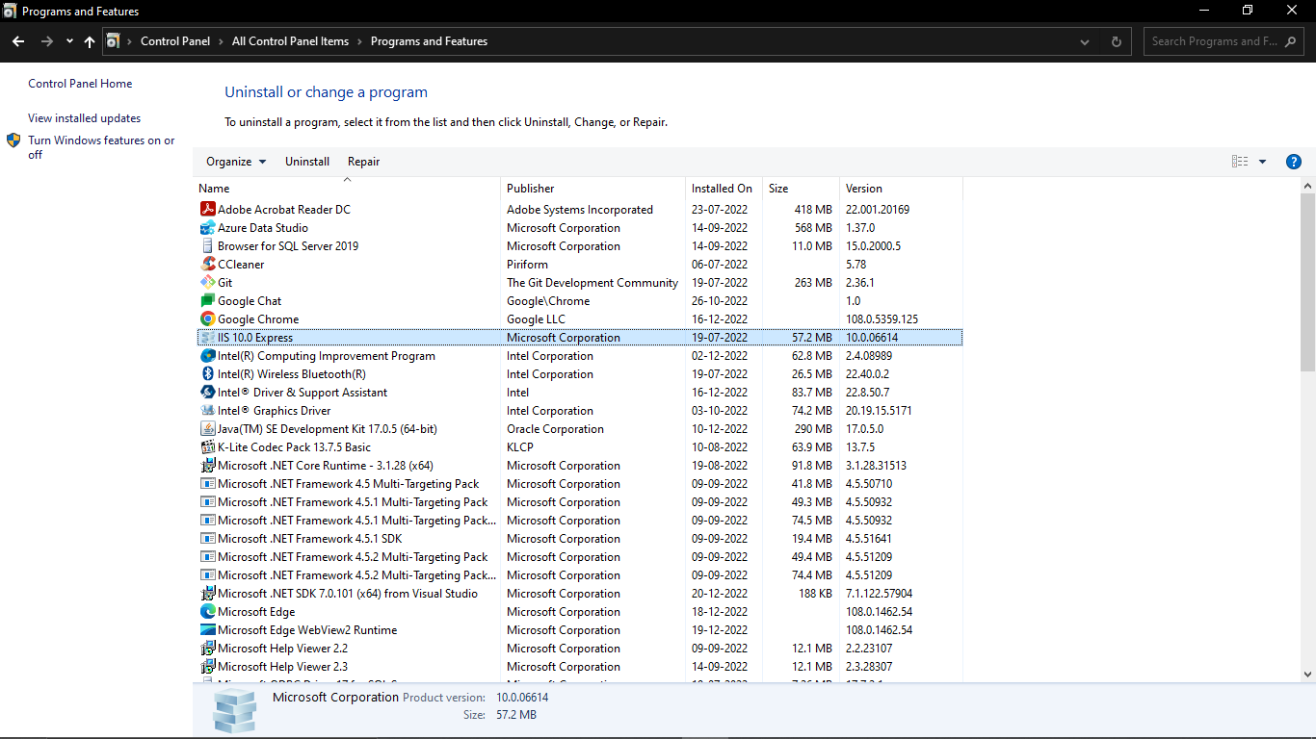

Step 3:- Search for the IIS Manager(Internet Information Manager) in windows search, here we’ll see the our database is connected to the IIS and we have to add site by right clicking the Sites folder

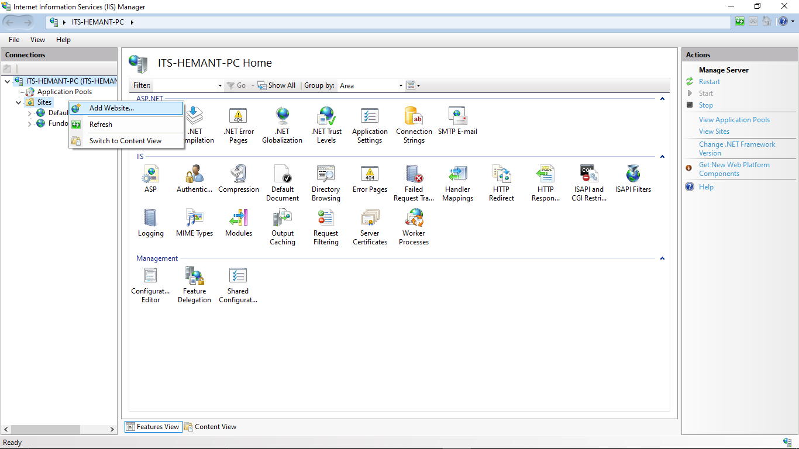

Step 4:- Now Add Website pop up window open. Here we have to do as follows:-

1. **Site Name** :- BookStoreApp
2. Click on Select and select Application pool as- **DefaultAppPool.** Then click **Ok**

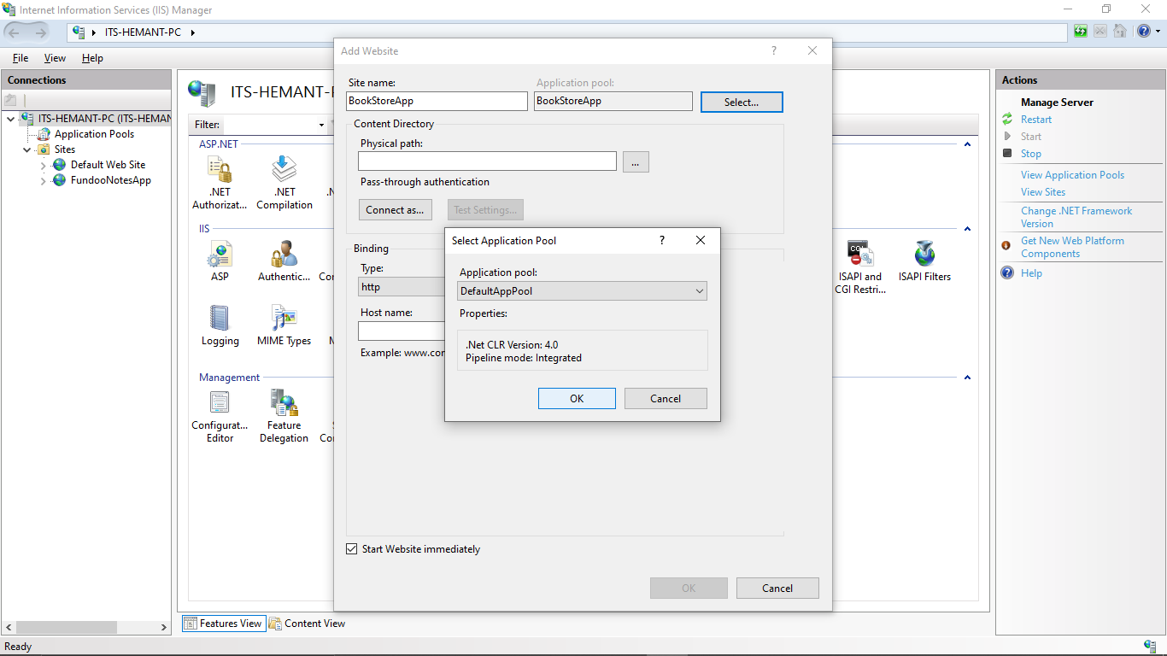

1. Physical Path: we have to select inetpub folder in the (C:) drive

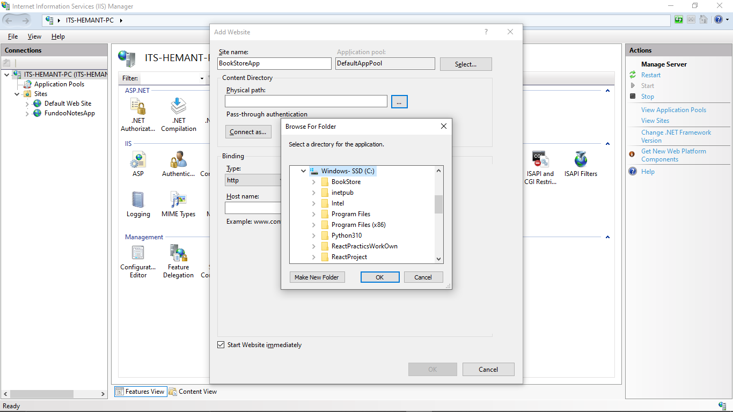

1. In the inetpub folder dropdown there is a wwwroot folder, here create new folder with name as BookStore.Then click Ok.

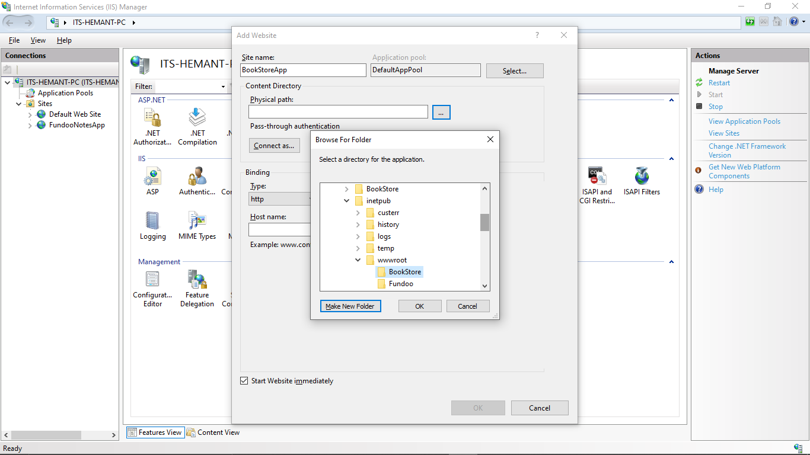

1. Binding: 1) select type as **http**

2) **IP address:-192.168.1.37**

3) **Port**:-**8082** - I have taken port 8082 we can choose any port number

4) Then click on ok

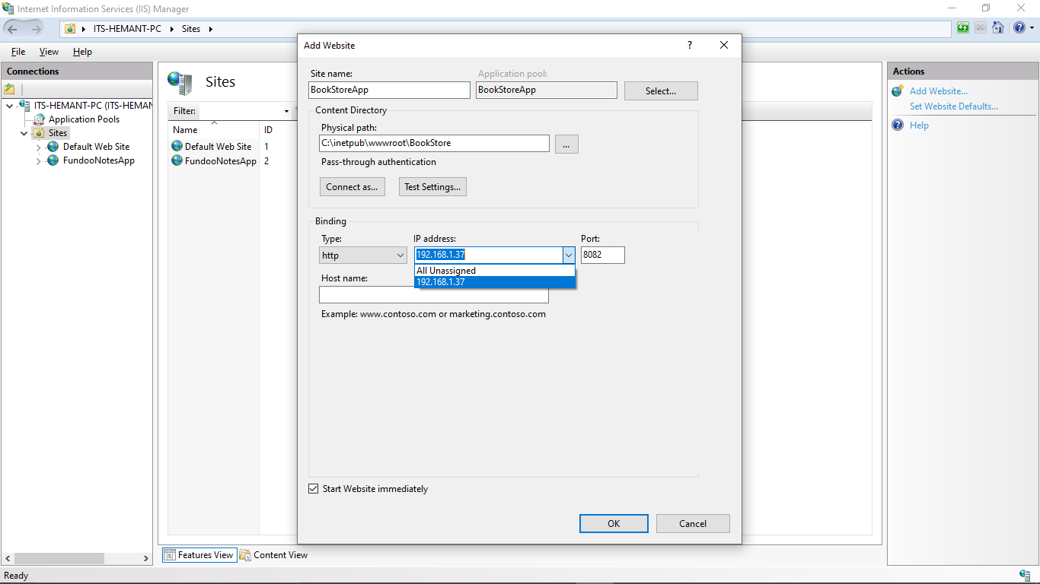

1. After completion of all steps our creates site is added in the Sites folder

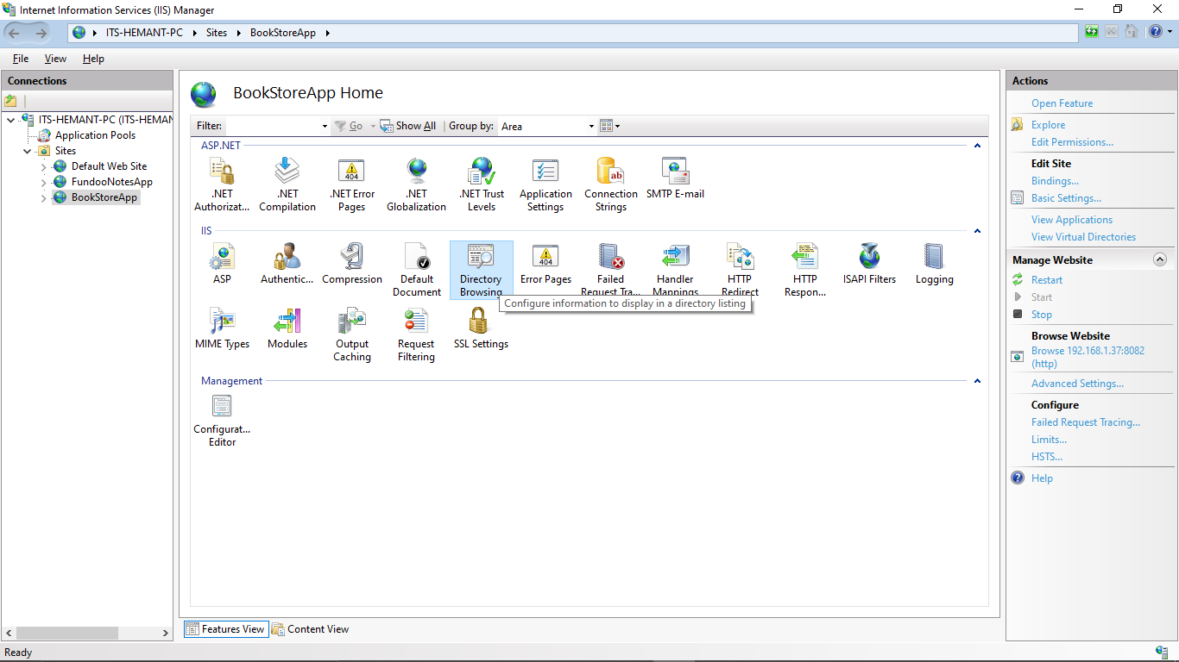

1. Search for the Directory Browsing present in IIS in dashboard and after clicking enable it (top right side below Alerts)

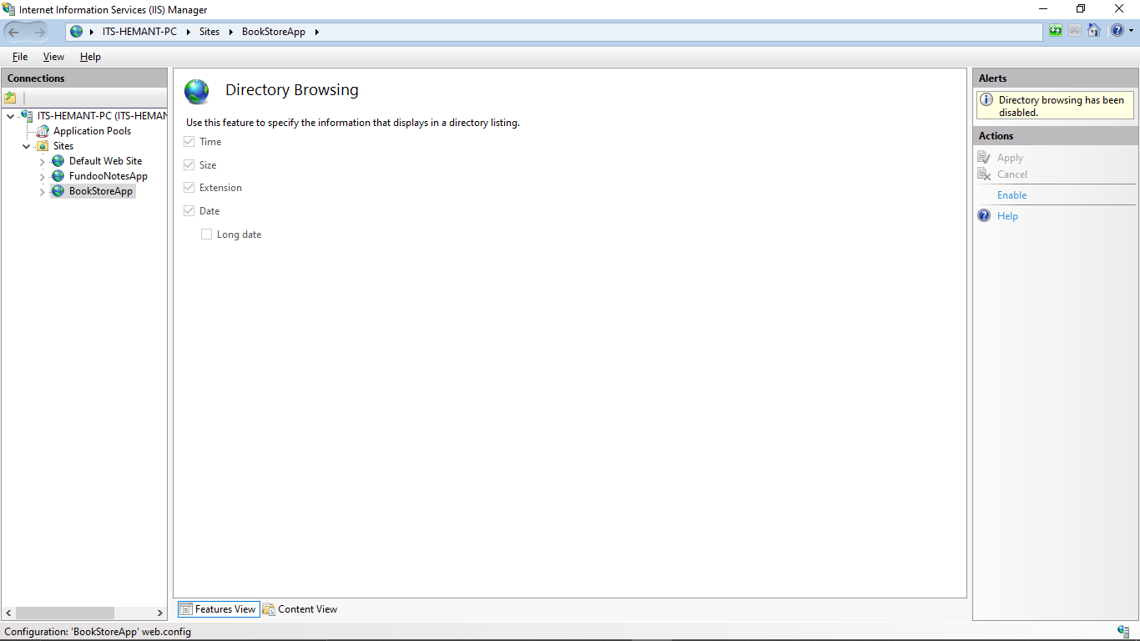

1. Here all set now In the Manage Website section (right side panel), search for the browse Website- here we get the IP address with port

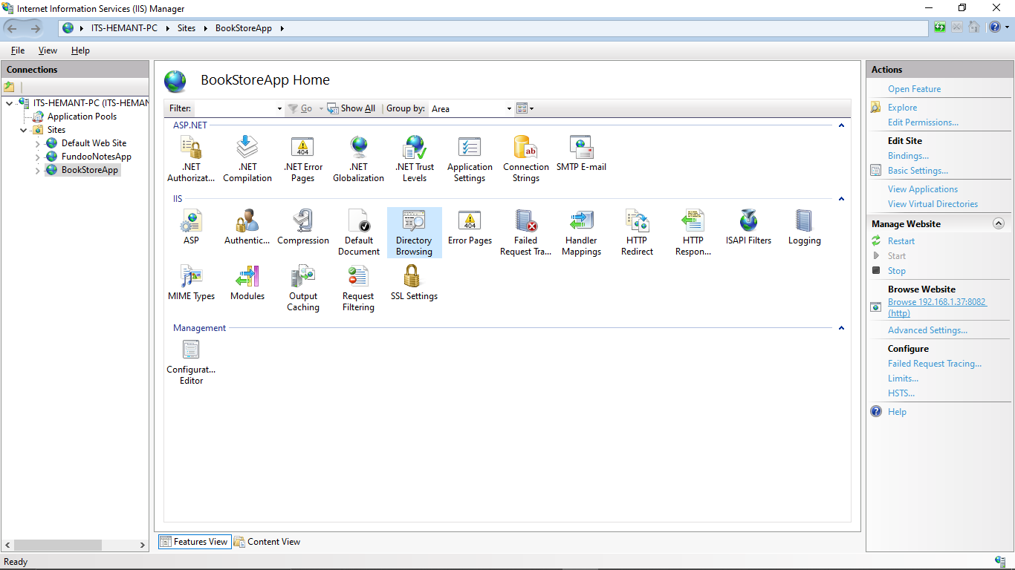

1. After clicking In Browser http page will open. If everything is perfect we’ll get a static page in browser or else we’ll get a error page.

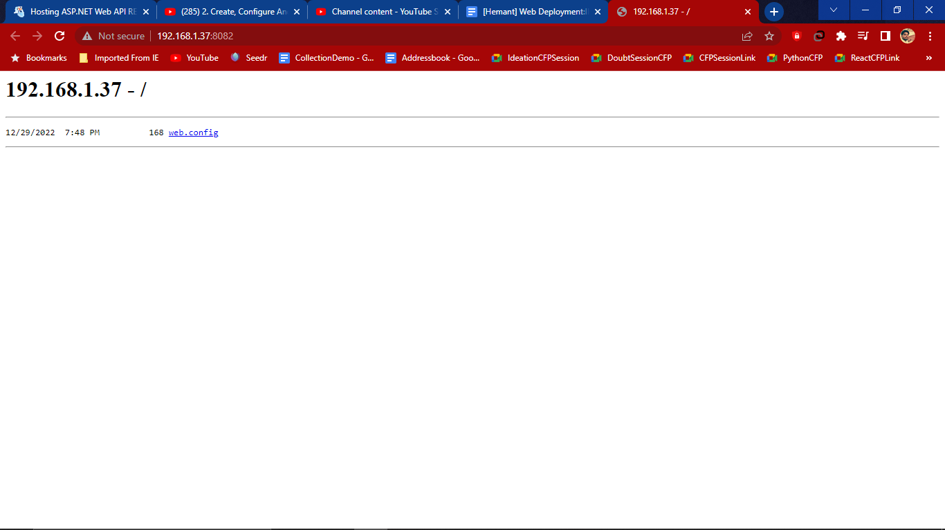

In case error occurs we get an error page(old error page that got when setting server for fundoo)

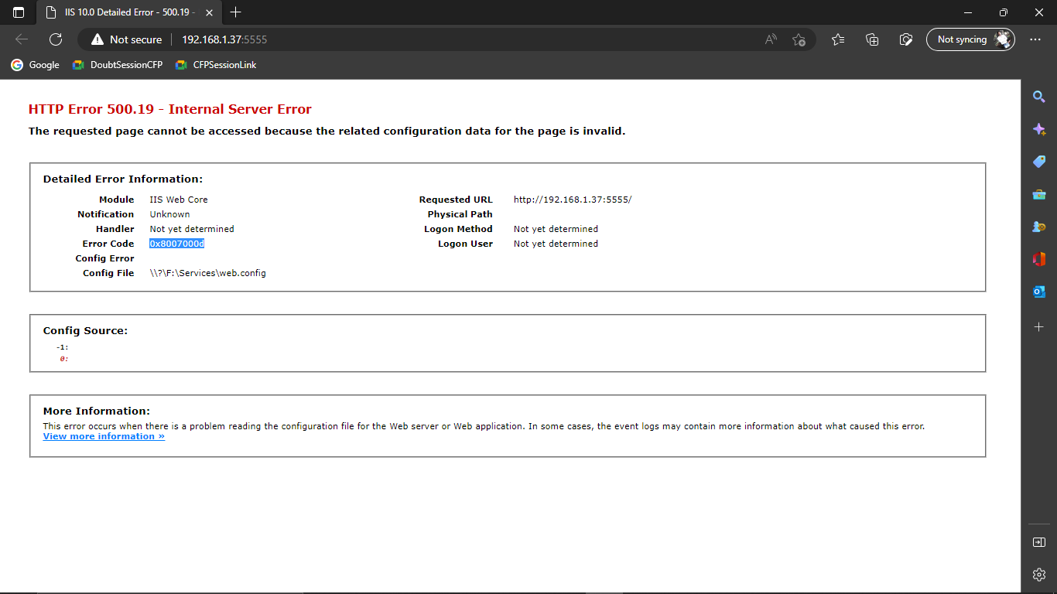

1. To check it go to the C:/ drive and inside **inetpub=>wwwroot=>BookStore=>web**

We get a service file

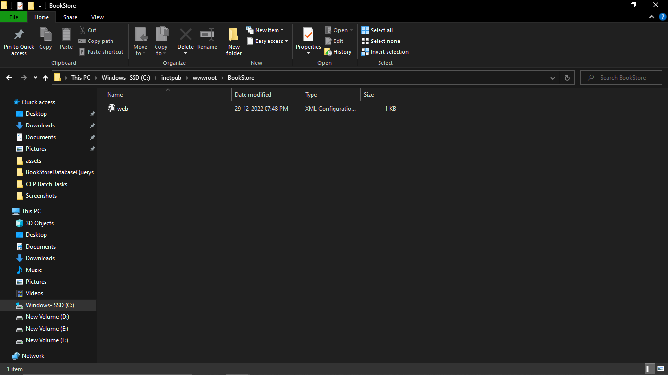

# Publish application

Step 1:- Open Visual studio code i.e BookStore that we have to publish on website

So for that open project and right click on project and **publish**=>select **folder**

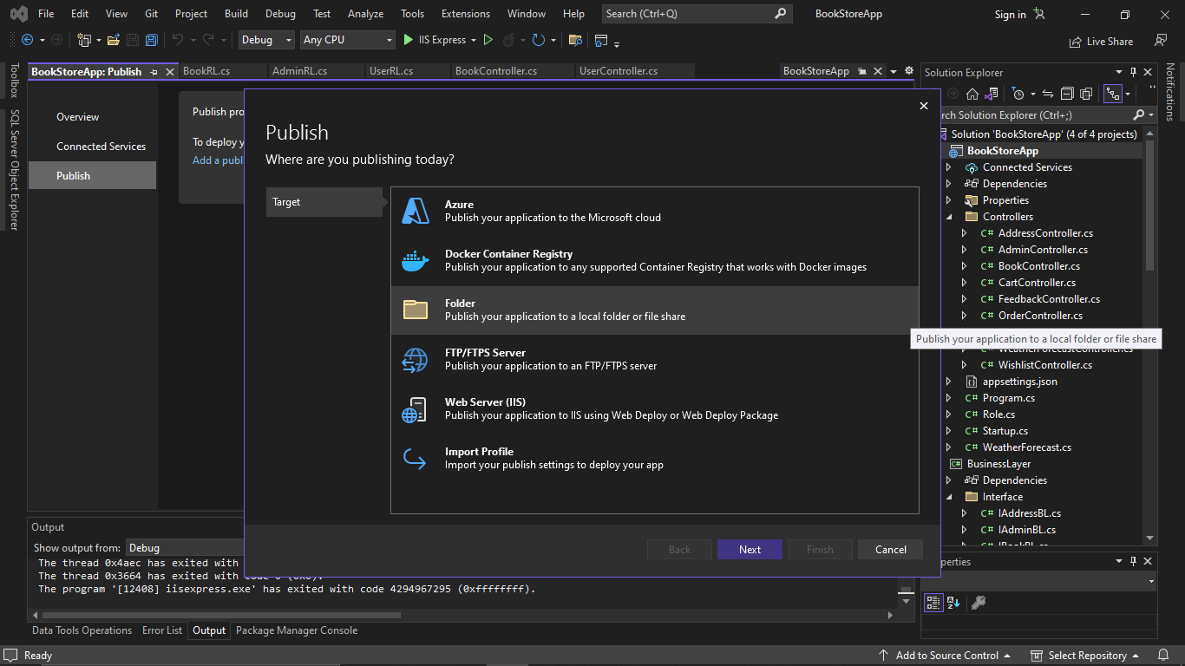

Step 2:-Click Next and set path/ Folder **bin\Release\netcoreapp3.1\publish\** and click Finish.Then

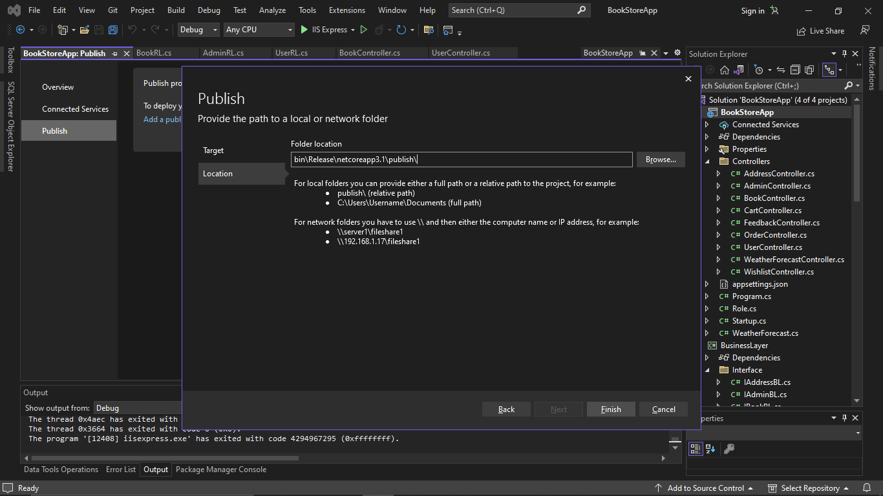

Here it is ready to publish when we click on publish

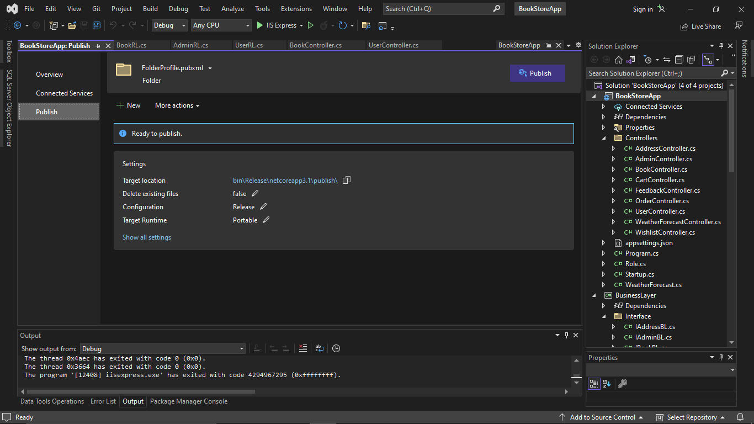

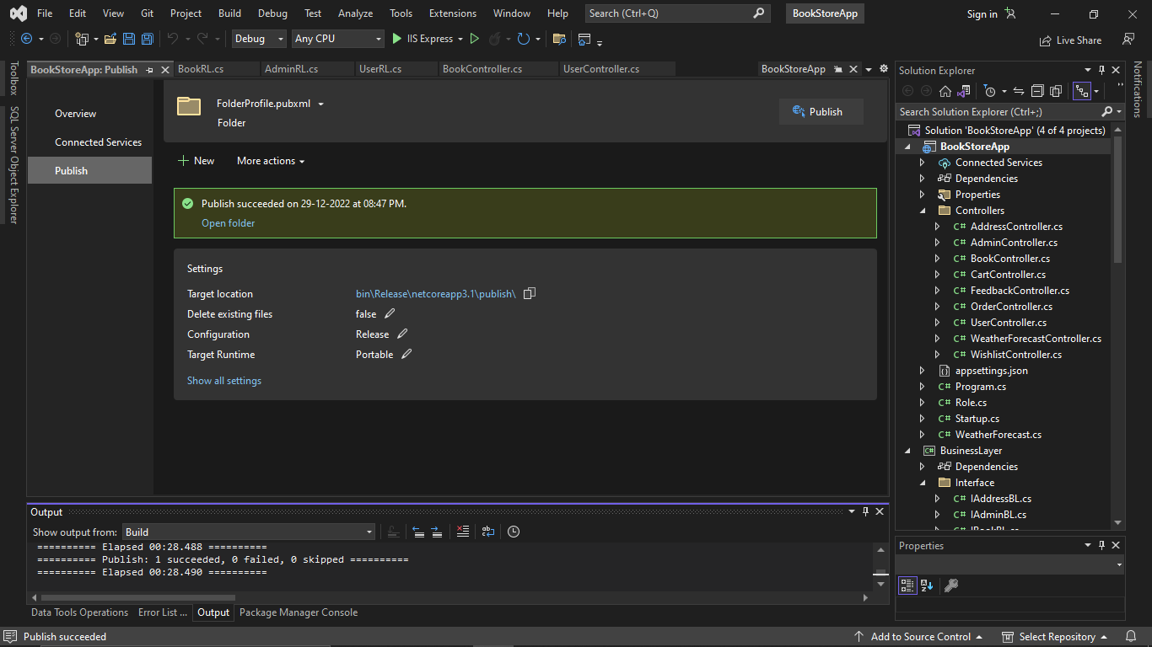

Step 3:- Now open the path where we have created publish just now by right clicking on project and open full path. It will redirect to the Visual studio code project folder

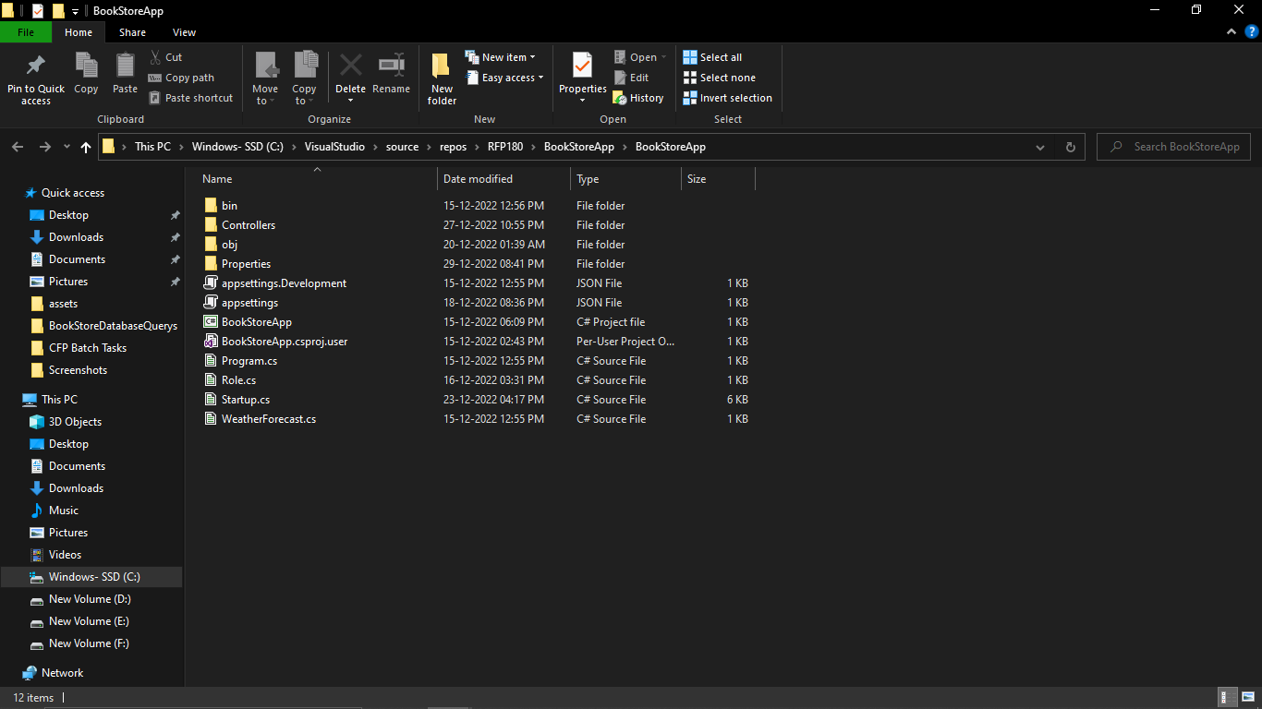

Step 4:- Go to the path

C:\VisualStudio\source\repos\RFP180\BookStoreApp\BookStoreApp\**bin\Release\netcoreapp3.1\publish\**

And copy publish folder and paste it in another folder so for now i have created in **F:/BookStoreWebHost** then paste it here publish folder

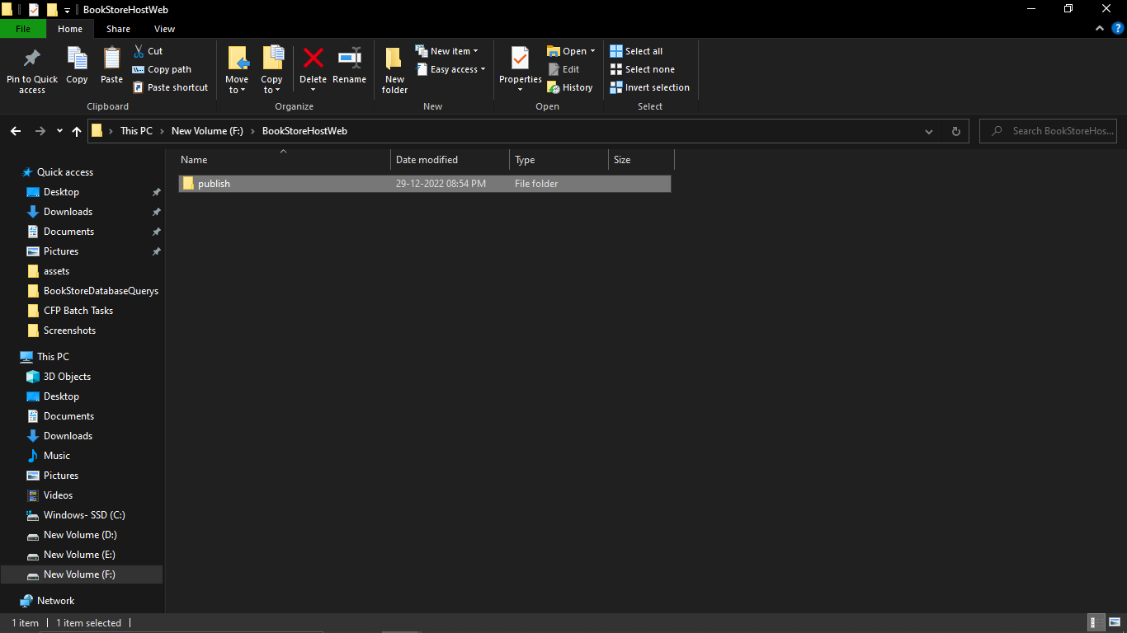

Step 5:- Now go to the IIS manager

And browse http link here page will open

